C/C++ DELETE REPEATS LAB REPORT

1) Enter your name, StudentID, platform (Mac or PC) and date
Name and Student ID: Brian Quintero 0842280
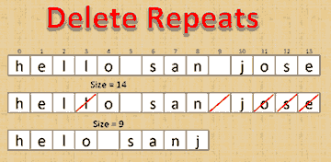
Class: CIS054 C/C++ Programming
Platform (Mac or PC): PC
Date: 4/3/17

PROJECT DESCRIPTION:
Create a function that deletes all repeating characters in a
C-string. Display a list of the characters that are being
deleted. Use a loop to identify the number of characters in
the string before and after the repeating characters have
been removed. Do not use any functions from the C or C++ string libraries.

LAB REPORT:
2) Determine the Inputs, Processing and Outputs before creating the program
INPUTS | PROCESSING | OUTPUTS
cin.getline(array, 100); | for (i = 0; i < size; i++)  {  do  {  deletefound = false;  for (j = i + 1; j < size; j++)  {  if (array[i] == array[j])  {  cout << array[i];  shiftleft(array, j, size - j);  deletefound = true;  size--;  }  }  } while (deletefound);  } | The updated array.

3) Fill in the EXPECTED & ACTUAL RESULTS
TEST DATA VALUES  Provide three different examples of strings with repeating characters | EXPECTED RESULT  Computed values before the program is run | ACTUAL RESULT  Fill in the output displayed  by the program
Race car is a name  Intro to CIS  Hi im Brian | Racer isnm  Intro CS  Hi mBrian | Racer isnm  Intro CS  Hi mBrian

DISCUSSION:
4) Complete the DISCUSSION section. It does not need to be long, but it needs to be complete.
4a) What problems did you have and how did you overcome the problems?
I did not know how to set up and array and how to find the same letters to delete.
My tutor helped me setup a formula he guided me but I ended up coming up with the overall answer. I did it a bit earlier in the week.

4b) When writing code, which looks more similar to pass by value, either pass by reference or pass by pointer? Why?

Pass by pointer, ive had more experience with it and my tutor has explained it a bit better for me.

PROGRAM OUTPUT:
5) Show at least THREE screen shots of the program execution of sample strings with repeating characters.
Refer to previous lab assignments for instructions on how to capture a screen
or portions of a screen for either the PC or Mac. Sample output:
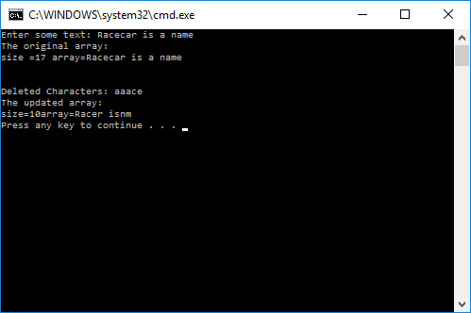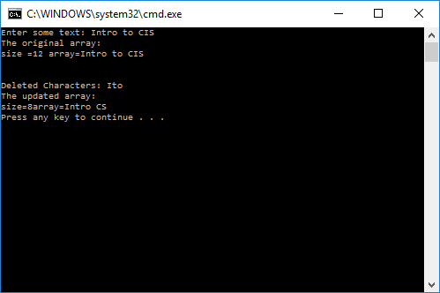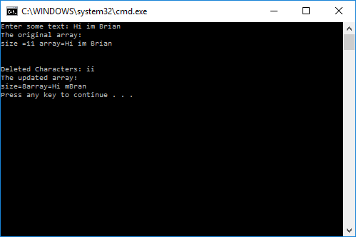

PROGRAM LISTING:
6) Copy and paste the code that YOU typed to make the program work. Your program should include a comment block at the top that shows the name of the program, date, version and your name.

// ConsoleApplication27.cpp : Defines the entry point for the console application.
//Brian Quintero 0842280
//Cis-054 C++
//Pc//4/3/17

#include "stdafx.h"
#include <iostream>
using namespace std;

void deleteRepeats(char *array, int &size);
void shiftleft(char *array, int index, int length);
int stringlength(char *);

int main()
{
char array[100];
cout << "Enter some text: ";
cin.getline(array, 100);
int size = stringlength(array);

cout << "The original array: " << endl;
cout << "size =" << size << " array=" << array << endl;
cout << endl << endl;
deleteRepeats(array, size);

cout << endl;
cout << "The updated array: " << endl;
cout << "size=" << size << "array=" << array << endl;

return 0;

}

int stringlength(char *array)
{
int i;
for (i = 0; array[i]; i++);
return i;

}

void deleteRepeats(char *array, int &size)
{
int i, j;
bool deletefound;

cout << "Deleted Characters: ";
for (i = 0; i < size; i++)
{

do
{
deletefound = false;
for (j = i + 1; j < size; j++)
{
if (array[i] == array[j])
{
cout << array[i];
shiftleft(array, j, size - j);
deletefound = true;
size--;
}

}

} while (deletefound);
}

}
void shiftleft(char *array,int index,int length)
{
for (int i = 0; i < length; i++)
{
array[index] = array[index + 1];
index++;

}
}

